# **Advanced Data Visualization – Lab #3**

|  |  |
| --- | --- |
| Provided files(s): | * Lab03_01.csv * Lab03_02.csv |
| Submission file(s): | * Lab03.docx * Lab03_1.twb * Lab03_2.twb |

Work in your regular groups. Please submit the submission file(s) through Blackboard. Only one person will submit for the group and only the last submission will be marked.

**Part I: Install Tableau Desktop**

This lab uses the standard Desktop version of Tableau. If you do not already have a licensed version of Tableau Desktop, go to the Tableau website and download either the [student version](https://www.tableau.com/academic/students) or the [trial version](https://www.tableau.com/products/trial) (this will work for two weeks, at which point your professor will have provided you with a product code to unlock a one-year academic license). If you have any trouble installing Tableau Desktop, ask your professor for help.

**Part I: Bar graphs**

1. Open Tableau Desktop.
   1. Choose Open >> File and select Lab03_1.csv.
   2. Create the bar graph shown below, with all details as shown.
   3. Add your name (for individuals) or your group number to the title of the chart.
   4. Paste the image here to replace the following figure.
   5. Save your tableau file as Lab03_1.twb and submit.

*Hints & Things to try*:

* Drag and drop the measures/dimensions you want to chart to Fund Balance to Marks >> Color.
* Right click the highest bar and choose Annotate >> Mark. Edit the recommended text (without writing the actual data values).

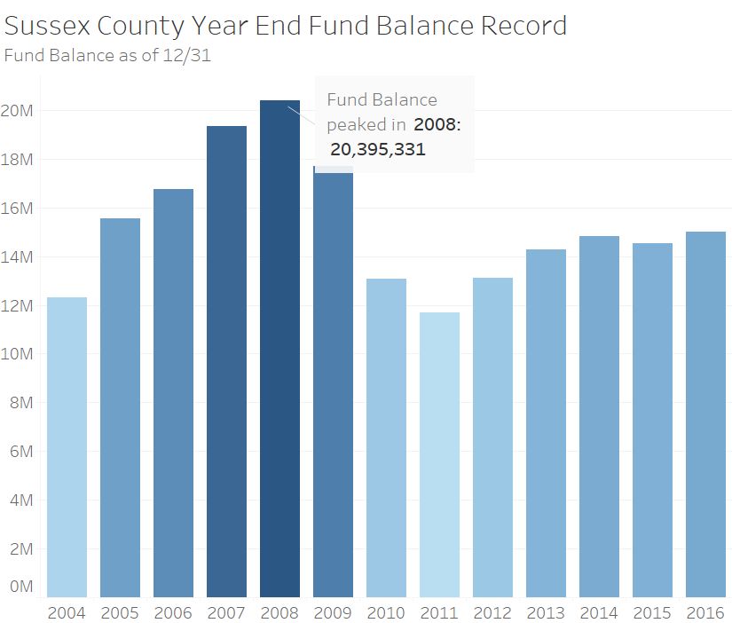

## **Part II: Line graphs**

1. Open Tableau Desktop.
   1. Choose Open >> File and select Lab03_2.csv.
   2. Create the line graph shown below, with all details as shown.
   3. Add your name (for individuals) or your group number to the title of the chart.
   4. Paste the image here to replace the following figure.
   5. Save your tableau file as Lab03_2.twb and submit.

*Hints* *& Things to try:*

* Right click the second pill in Rows and choose Dual Axis.
* Right click Y-axis and choose Synchronize Axis.
* Right click the rightmost point on each line and choose Annotate >> Point to add the legend next to each line series
  + Choose the text color by More colors >> Pick Screen Color and clicking on the legend colors
  + Format the annotation and turn off shading and line

